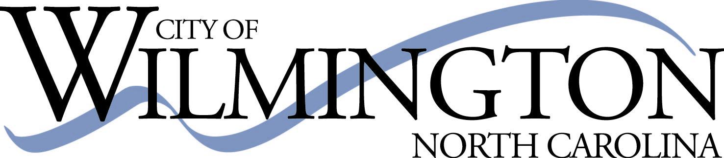

PARKS & RECREATION ADVISORY BOARD MEETING AGENDA
SEPTEMBER 21, 2022, 5:30PM
401 S. 8th St., Martin Luther King Center

Call to Order

- Approval of June & August 2022 minutes
  - June minutes were not approved due to not enough Board members being present for a quorum. Minutes from the special meeting in July do not require approval.

- Approval of August agenda

- WMPO Presentation on Quarter Cent Sales Tax
Mike Kozlosky, Executive Director
Wilmington Urban Area Metropolitan Planning Organization (WMPO)

- Accessibility for Parks Grant (need vote of support) -Davina Bell

- Old Business
  - Staff to provide brief refresher of the By-Laws
  - Greenfield Lake Masterplan schematic design update
  - P & R Comprehensive Plan update
  - Wade Park community event update

- New Business
  - Vote to appoint Chairperson

- Staff Report
  - Recognize Davina’s positive impact as she steps away from PRAB staff liaison role
  - 2 vacancies- Recognize members rolling off, please share this opportunity with your network
  - Propose SWOT analysis activity at next meeting to brainstorm Board activities and inform annual work plan (SWOT = Strength, Weaknesses, Opportunities, Threats)

- Adjournment

Next Meeting: Wednesday, October 19, 5:30PM, MLK Center

